

FACULTY OF INFORMATION AND COMMUNICATION TECHNOLOGY

DCOMP204 – WEB DESIGN 1

Title : Individual Assignment 2
Issue Date : Week 4
Due Date : Week 7
Lecturer/Examiner : N’yillah Borteh Conteh
Name of Student/s : Mr Amadu Kamara
Student ID No. : 905005504
Class : BIT 1104F
Year/Semester : 2/1

Academic Honesty Policy Statement

I/We, hereby attest those contents of this attachment are my own work. Referenced works, articles, art, programs, papers or parts thereof are acknowledged at the end of this paper. This includes data excerpted from CD-ROMs, the Internet, other private networks, and other people’s disk of the computer system.

Student’s Signature: Date: 29th NOVEMBER 2025
LECTURER’S COMMMENTS/GRADE:

for office use only upon receive
Remark

DATE:
TIME:
RECEIVER’S NAME:

HOME PAGE SCREENSHOT
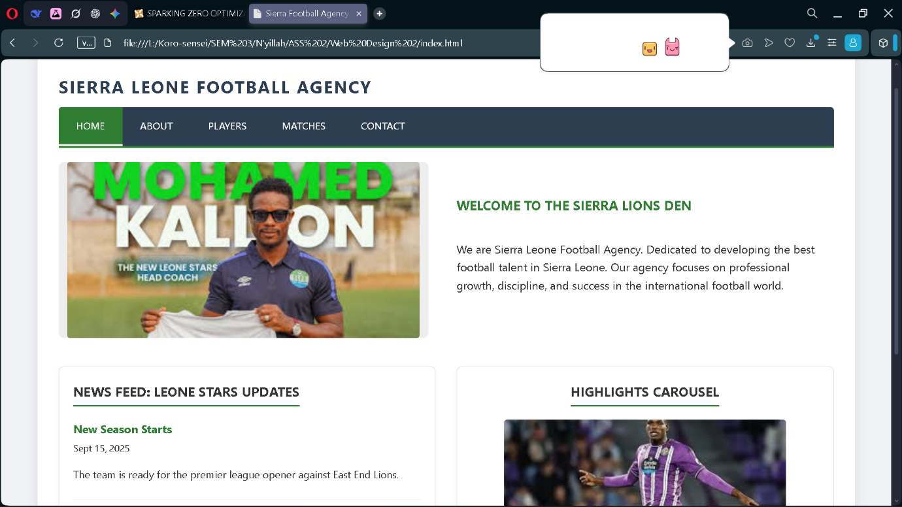

PLAYERS PAGE SCREENSHOT
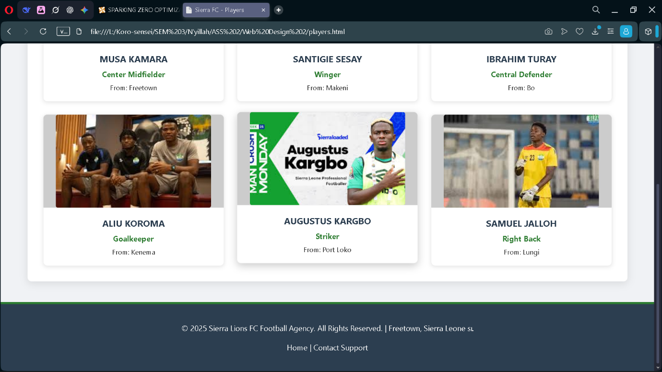

CONTACT PAGE SCREENSHOT
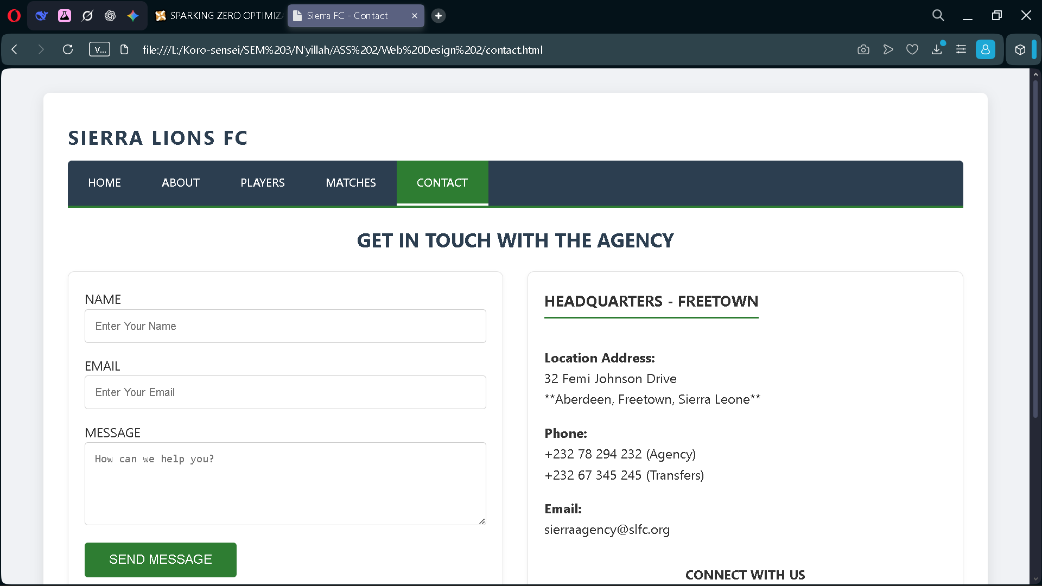

MATCHES PAGE SCREENSHOT

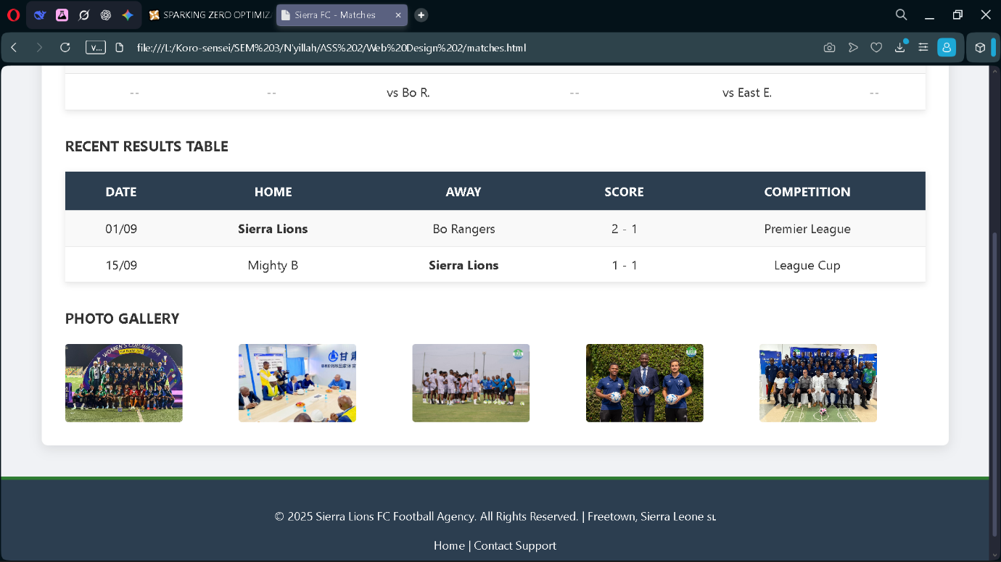

ABOUT US PAGE SCREENSHOT

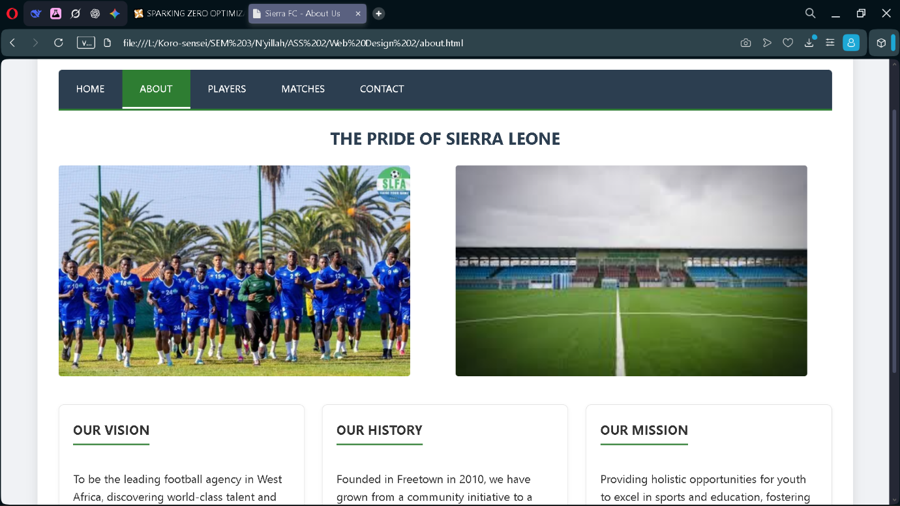

HOME PAGE CODE
<!DOCTYPE html>
<html lang="en">
<head>
<meta charset="UTF-8">
<title>Sierra Football Agency - Home</title>
<link rel="stylesheet" href="style.css">
</head>
<body>
<div class="container">
<div class="page-title"></div>

<header class="header-section">
<h2 class="brand-name">SIERRA Leone Football Agency</h2>
<nav>
<a href="index.html" class="active">HOME</a>
<a href="about.html">ABOUT</a>
<a href="players.html">PLAYERS</a>
<a href="matches.html">MATCHES</a>
<a href="contact.html">CONTACT</a>
</nav>
</header>

<div class="hero-section">
<div class="hero-image-placeholder">
<img src="kallon.jpg" alt="Stadium Banner" width="500" height="250">
</div>
<div class="intro-text">
<h3>WELCOME TO THE SIERRA LIONS DEN</h3>
<p>We are Sierra Leone Football Agency. Dedicated to developing the best football talent in Sierra Leone. Our agency focuses on professional growth, discipline, and success in the international football world.</p>
</div>
</div>

<div class="grid-2">
<div class="content-box">
<h3>NEWS FEED: LEONE STARS UPDATES</h3>
<div style="margin-bottom:15px; border-bottom:1px solid #eee; padding-bottom:10px;">
<strong style="color:#2E7D32;">New Season Starts</strong><br>
<small>Sept 15, 2025</small>
<p style="font-size:0.9rem;">The team is ready for the premier league opener against East End Lions.</p>
</div>
<div>
<strong style="color:#2E7D32;">Player Transfer News</strong><br>
<small>Aug 20, 2025</small>
<p style="font-size:0.9rem;">Three new academy players promoted from Kono District to senior squad.</p>
</div>
</div>
<div class="content-box" style="text-align: center;">
<h3>HIGHLIGHTS CAROUSEL</h3>
<img src="juma bah.jpg" alt="Highlights" width="400" height="150" style="margin: 0 auto 10px auto;">
<p><strong>Goal of the Month:</strong> Juma Bah vs East End Lions</p>
</div>
</div>
</div>

<footer>
<p>&copy; 2025 Sierra Lions FC Football Agency. All Rights Reserved. | Freetown, Sierra Leone 🇸🇱</p>
<p>
<a href="index.html">Home</a> |
<a href="contact.html">Contact Support</a>
</p>
</footer>
</body>
</html>

